# Assessment Task 1 - In-Class Group Workshop Week 2

1. Develop a Java Program that allows the user to input their pay and find out 10% from it and display it as a saving.

Ans:

/**

*

*/

package week02;

import java.util.Scanner;

/**

*

*/

public class SalarySavings {

/**

* @param args

*/

public static void main(String[] args) {

// Create a Scanner object to read user input

Scanner scanner = new Scanner(System.in);

// Prompt the user to enter their pay

System.out.print("Enter your pay: ");

double pay = scanner.nextDouble();

// Calculate 10% of the pay as savings

double savings = pay * 0.10;

// Display the calculated savings

System.out.printf("Your savings (10%% of your pay) are: %.2f\n", savings);

// Close the Scanner object

scanner.close();

}

}

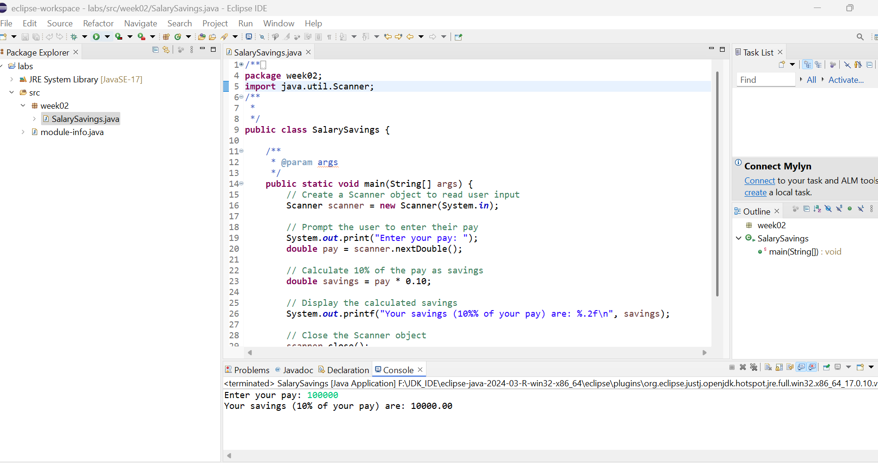

1. Develop a Java Program that allows the user to input a set of 4 marks. The program calculates and output the total.

Ans:

/**

*

*/

package week02;

import java.util.Scanner;

/**

*

*/

public class TotalMars {

/**

* @param args

*/

public static void main(String[] args) {

// Create a Scanner object to read user input

Scanner scanner = new Scanner(System.in);

// Declare an array to store 4 marks

int[] marks = new int[4];

int total = 0;

// Prompt the user to input 4 marks

System.out.println("Enter the marks for 4 subjects:");

for (int i = 0; i < 4; i++) {

System.out.print("Enter mark " + (i + 1) + ": ");

marks[i] = scanner.nextInt();

total += marks[i]; // Add each mark to the total

}

// Display the total marks

System.out.println("The total marks are: " + total);

// Close the Scanner object

scanner.close();

}

}

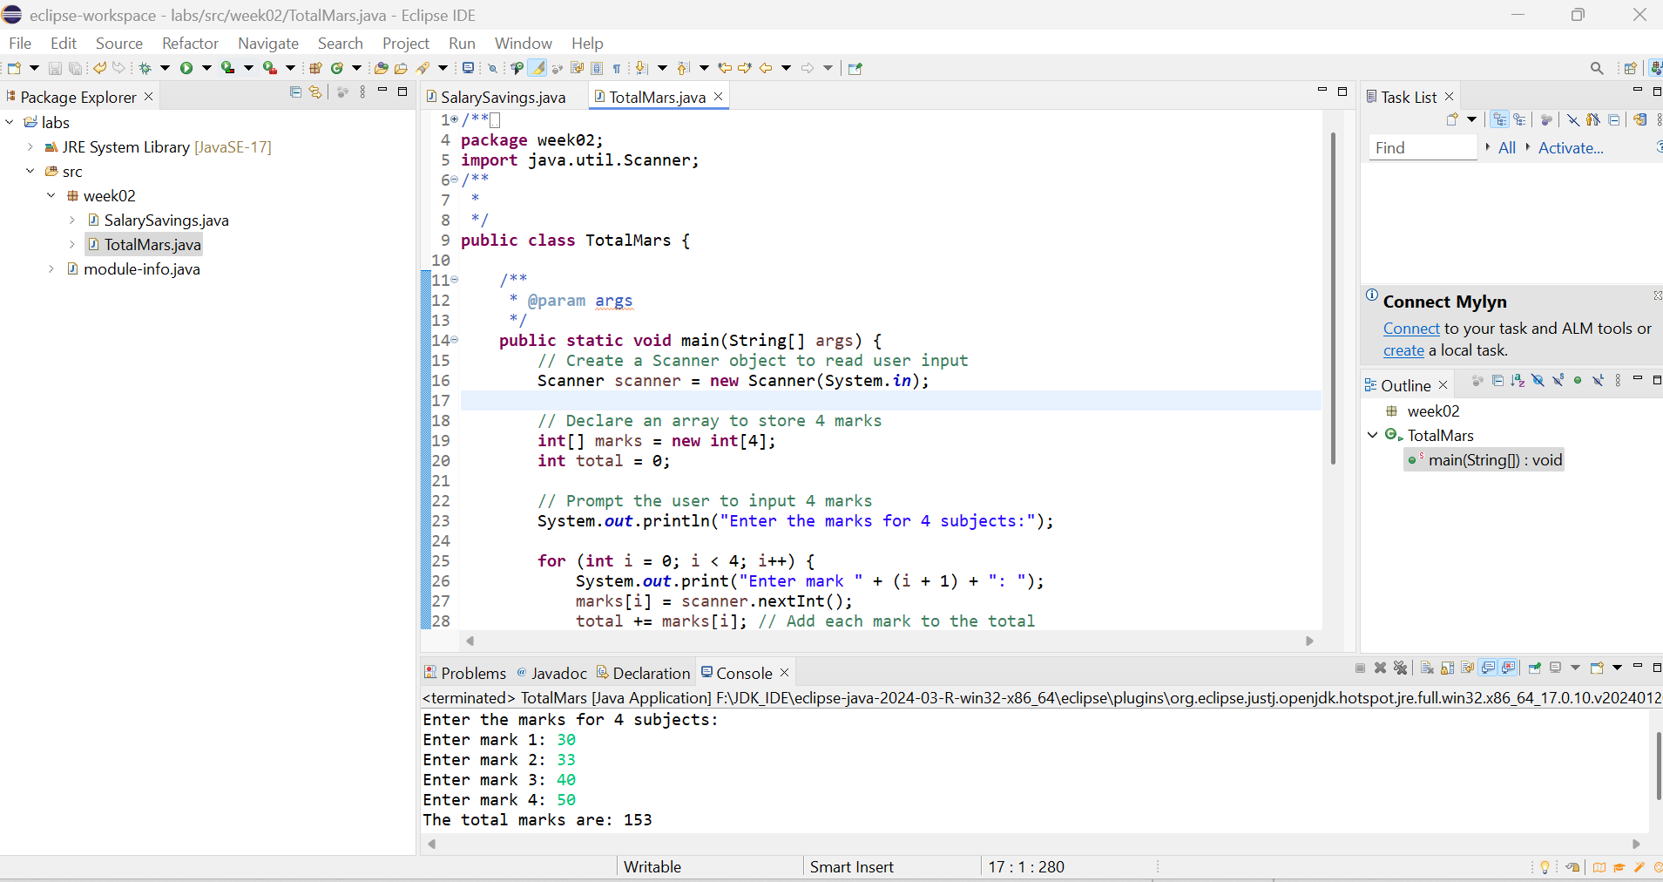

1. Develop a Java Program that allows the user to enter three values and display the multiplication of all values.

Ans: /**

*

*/

package week02;

import java.util.Scanner;

/**

*

*/

public class ValueMultiplication {

/**

* @param args

*/

public static void main(String[] args) {

// Create a Scanner object to read user input

Scanner scanner = new Scanner(System.in);

// Prompt the user to enter three numbers

System.out.print("Enter the first number: ");

double num1 = scanner.nextDouble();

System.out.print("Enter the second number: ");

double num2 = scanner.nextDouble();

System.out.print("Enter the third number: ");

double num3 = scanner.nextDouble();

// Calculate the multiplication of the three numbers

double result = num1 * num2 * num3;

// Display the result

System.out.println("The multiplication of the three numbers is: " + result);

// Close the Scanner object

scanner.close();

}

}



 